Week 1 Task: Data Cleaning and Preliminary Analysis with R
Dataset: Titanic Passenger Dataset

1. Task Objective & Dataset Selection
The primary objective of this project is to perform end-to-end data preprocessing, cleaning, and preliminary exploratory data analysis (EDA) using R. For this assignment, the publicly available Titanic Passenger Dataset was selected. The dataset contains 891 observations and 12 variables comprising both numerical and categorical attributes.

2. Data Cleaning Methodology
- Handling Missing Values:
* Age: 177 missing entries were imputed using the median value (28 years) to avoid skewness from outliers.
* Embarked: 2 missing entries were filled using the mode value ('S' - Southampton).
* Cabin: Dropped completely due to over 70% missing values.
- Outlier Detection & Treatment:
* Fare values exhibited severe right skewness. Outliers were capped using Tukey's IQR rule (Q3 + 1.5 * IQR) to prevent data loss while normalizing variance.
- Encoding & Standardization:
* Converted Sex, Embarked, Pclass, and Survived into categorical factors.
* Standardized continuous variables (Age and Fare) using the scale() function.

- Visualizations & Preliminary Insights

Figure 1: Survival Distribution Barplot — Mortality rate exceeds 61%, highlighting severe disaster.

.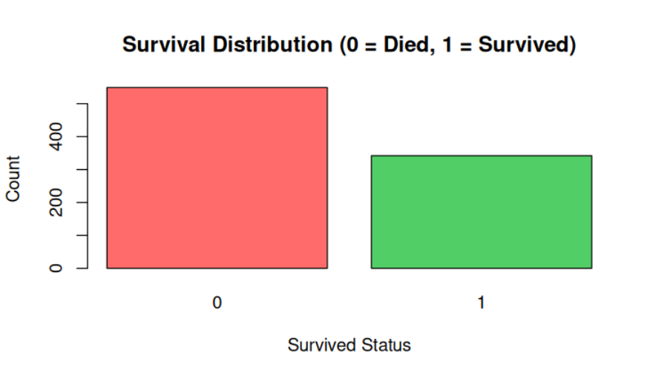
Figure 2: Age Distribution Histogram — Displays peak concentration between 25 and 32 years post-median imputation.
.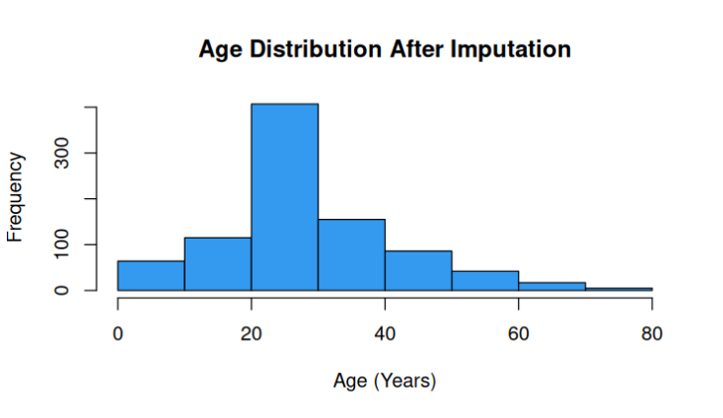 Figure 3: Fare Outlier Boxplots (Before vs After Capping) — Shows successful containment of extreme ticket prices via IQR thresholds.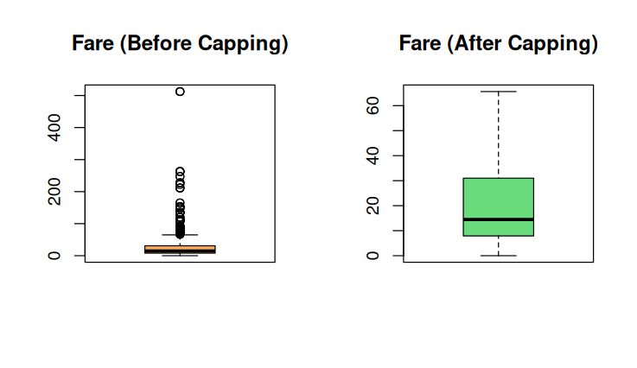Figure 4: Correlation Matrix Plot — Highlights moderate positive correlation between SibSp and Parch (family travel dynamics).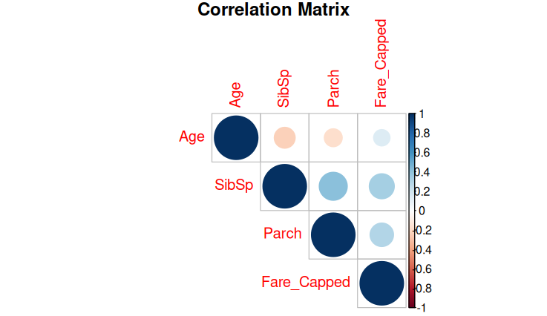 Summary & Conclusion
The entire cleaning and exploratory pipeline in R successfully handled all data anomalies, treated missing values and outliers systematically, and produced a normalized dataset ready for advanced predictive modeling.

